Fast Prediction of 3D Printing Optimal Orientation  
Using General-Purpose Graphic Card Unit Calculation

Jae Ryoung Kim, Heeran Lee, and In Hwan Sul†

Department of Materials Design Engineering, Kumoh National Institute of Technology, Gumi 39177, Republic of Korea

†: All correspondences to In Hwan Sul ([snowman0@kumoh.ac.kr](mailto:snowman0@kumoh.ac.kr))

# Abstract

This paper proposes a fast parallel computation algorithm that can predict the optimal orientation of 3D printing with the aid of general-purpose graphic card unit (GPGPU) . Previously, we proposed the support structure tomography that approximates the amount of support structure as the shadow volume from virtual sunlight, and it showed that the calculation speed was about 1 second per orientation for 65k triangular mesh data. The previous algorithm was converted to a GPU-friendly form NVIDIA graphic cards and CUDA toolkit. Despite several bottlenecks, calculation speed was improved by 10 to 45 times.

# Keywords

3D printing; optimal orientation; support structure tomography; GPGPU; NVIDIA CUDA

# Introduction

Three-dimensional printing (*3DP*), which is also known as rapid prototyping (*RP*) or additive manufacturing (*AM*) [1], is a typical example of the fourthindustrial revolution and is applied to various areas, including mechanical and aerospace [2] engineering, architecture [3, 4], agriculture [5], food industry [6], medical [7], and bio-industry [8, 9]. It is useful when low production volumes, high design complexity, and frequent design changes are required. Its limitations [10] include void formation, anisotropic mechanical properties, and relatively small build volume to CNC machines. The biggest obstacle among them is the support structure (*SS*). Most 3D printers, except for the selective laser sintering (*SLS*) type, require it when the inclination of the polymer stacks is above a certain critical angle. It increases the total printing time and filaments and leads to an unsmooth surface owing to the stair-casing effect [11].

Printer users can use several options to minimize the *SS*. Dai et al. [12] reduced the *SS* by rotating the printer bed. However, such a particular device is not feasible for ordinary consumers, and this study assumed that the movement of the bottom plate follows that of typical fused deposition modeling (FDM) printers.

The other approach is to find the optimal orientation in advance theoretically. It can be done either explicitly or implicitly. The explicit method calculates the amount of support structure via direct slicing. To accelerate the calculation, Wang et al. [13] and Das [14] voxelized the target mesh data and reduced the G-code generation time using a graphics processor unit (*GPU*). Their work showed successful g-code and, thereby, *SS* information for a specific orientation but not applied to optimal orientation search, presumably due to computation burden [15]. The implicit method indirectly calculates the amount of SS without g-code generation. Ezair et al. [16] observed that the volume of a support structure is similar to that of an object’s shadow volume from virtual sunlight. Their idea was simple and intuitive. However, it applied only to a case of zero filament critical angle. Our team [17] developed it to a more general form to use any critical angle. We designated the new idea as “modified support structure tomography (*MSST*)” [17, 18], as the resultant distribution of *SS* resembled medical X-ray figures somewhat. The MSST was applied to several well-known meshes, such as Stanford Bunny, and it showed almost the same SS results as conventional slicing software. The only drawback was calculation speed. Our previous method took about one second for a single orientation SS calculation of 65k Bunny. Still, it should be iterated with respect to the X-axis (yaw) and Y-axis (pitch) direction for optimal orientation search. For example, if the search step (***θ****yp*) to the yaw and pitch is 1° respectively, 360 × 360 = 129,600 iterations are needed, and the CPU-based MSST will take one to two minutes for 65k Bunny.

By the way, deep learning technologies such as chatGPT have been developed intensively in the last decade. The main reason would be that the internet provided a massive amount of data, and the hardware, such as NVIDIA’s graphic card unit (*GPU*) or Google’s tensor unit (*TPU*), have been able to deal with the big data efficiently [19, 20]. For example, the learning of *GPU*-based chatGPT-3.5 was 1,000 times faster [21] than the central processing unit (*CPU*), although it had 96 layers and 175 billion parameters [19]. The original role of GPU started with sending pixel color data to the display device. However, the advancement of 3D games boosted the performance of GPUs and vice versa.

Meanwhile, some scientists have started to use the GPUs' parallel computing power for general-purpose calculations. NVIDIA, one of the significant GPU companies, opened a C-language-based software development toolkit (SDK) “CUDA” in 2007 [22], and its versatility made it the standard for general-purpose graphic card unit (GPGPU) calculation. However, the bottleneck of GPUs is that their hardware structure still limits them, so conventional CPU-friendly algorithms can only partially utilize the GPU's parallel computing power.

This paper converted our previous CPU-version MSST algorithm [23] to a GPU-friendly one to predict the optimal orientation of a complex 3D mesh object quickly and in a reasonable time. Chapter 2 briefly reviews our previous MSST algorithm and explains the new GPU version. Chapter 3 introduces the hardware and mesh data used. Chapter 4 compares and discusses the performance between CPUs and GPUs.

# Modeling

## Brief review of our previous work

### CPU-MSST [17, 18, 24]

Figure 1 illustrates Ezair et al.’s idea [16]. The target object to be printed is laid on the printer bed (Figure 1a). Virtual sunlight is projected from the far +Z axis direction, and the objects' top-covering (*TC*) surfaces make a shadowed volume (Figure 1b). As the object’s volume (***V****o*) is constant (Figure 1c), the volume of SS (***V****ss*, Figure 1d) can be known by Eq. (1).

$V_{ss}=V_{tc}-V_{o}$ (1)

, where the graphic card’s depth test can easily give the top-covering volume (***V****tc*).

|  |  |
| --- | --- |
| (a) | (b) |
| (c) | (d) |

Figure 1**.** Ezair et al. [16]’s implicit support structure calculation scheme (a) target object, (b) Calculating top-cover volume using GPU, (c) calculating object volume, and (d) final support structure volume (=*Vtc*-*Vo*) [25]

By the way, Eq. (1) is applicable only when the filament critical angle (***θ****c*) is zero, which means that every overhang needs a support structure, as shown in Figure 1d. Most 3DP uses polymeric filaments, and they have ***θ****c* value between 45°~60°, which means that some overhang does not need *SS*. Thus, the more general form of Eq. (1) will be Eq. (2)

$V_{ss}=V_{tc}-V_{o}-V_{nv}$ (2)

, where ***V****nv* represents the non-overhang volume, which is a function of ***θ****c*.

### Pixel-slot-based volume integration

Calculating ***V****nv* is the tricky part of the *MSST*. The occlusion between the overhang surface and the bottom plate made *SS* volume in Figure 1d. However, most of the real-life objects have more complex surface-to-surface occlusion. To deal with this, we split the virtual sunlight of Figure 1 into multiple rays. Figure 2 illustrates this approach. Each ray meets the object's surface, and we designate the intersection points as “pixels.” Figure 2a shows four pixels from the same ray. We sort these pixels by the z-coordinates and designate them as “pixel slots.” Then, the pixels facing the virtual sun direction (+*Z*) are called α pixels, and those facing the bottom plate are *β* pixels. Interestingly, integrating the *Z*-components of those pixels can give object volume like Eq. (3) [17].

$V_{o}=V_{α}-V_{β}$ (3)

And then inserting Eq.(3) to Eq.(2) gives the Eq. (4)

$V_{ss}=V_{tc}-V_{o}-V_{nv}= V_{tc}-(V_{α}-V_{β})-V_{nv}$ (4)

Also, we can easily find a TC pixel equivalent to the highest *α* pixel in the slot (*α0* in Figure 2a). It is also added to the current pixel group and the bottom intersection point. And then, surface-to-surface occlusion intervals are found, such as (*β0*, *α1*) and (*β1*, *bottom*). These intervals are candidates for either *SS* or *NV*. For example, all the intervals will be *SS* if ***θ****c* is zero (Figure 2b). Otherwise, some will be NV, depending on the overhang’s inclination angle (Figure 2c).

|  |  |  |
| --- | --- | --- |
| (a) after  pixelization | (b) θc=0° | (c) θc=60° |
|  | | |

Figure 2. Classification of pixel types in a pixel slot (x,y). [18]

Repeating the procedure of Figure 2c for every area of the target object can give the filament volume information such as ***V****α*, ***V****β*, ***V****tc*, ***V****o*, and ***V****ss* for a specific orientation. Figure 3 is the schematic overview of the *MSST* algorithm for a simple boat-like shape.



Figure 3**.** Schematic overview of our modified support structure tomography method for a simple boat-like shape [18]

### Volume-to-mass conversion

3D Printers do not fill the inside volume for printing speed. We dissected the object volume (***V****o*) into external shells (“clad”) and internal (“core”), like Eq. (5) and Eq.(6) [24].

$V_{o_clad}={(I+J)∙T_{clad}}$ (5)

$V_{o_core}=V_{o}-V_{o_clad}$ (6)

With I and J representing the number of α and β pixels and Tclad denoting the thickness of the clad, the value of which is derived from the g-code options, the volume-to-mass conversion process is straightforward and uncomplicated, as demonstrated in Eq. (7)-(12). This simplicity should instill confidence in its application.

$M_{o_clad}={V_{o_clad}∙F_{clad}∙ρ_{PLA}}$ (7)

$M_{o_core}={V_{o_core}∙F_{core}∙ρ_{PLA}}$ (8)

$V_{ss_clad}={V_{ss}-V_{ss_clad}}$ (9)

$M_{ss_clad}={V_{ss_clad}∙F_{clad}∙ρ_{PLA}}$ (10)

$M_{ss_core}={V_{ss_core}∙F_{core}∙ρ_{PLA}}$ (11)

$M_{total}={M_{o}+M_{ss}}$

$={(M_{o_clad}+M_{o_core})+{(M}_{ss_clad}+M_{ss_core}})$ (12)

, where ***Fclad***, ***Fcore***, and ***ρPLA***represent the clad fill ratio, core fill ratio, and filament density [24].

### Orientation contour graph

To find the optimal printing orientation, we need to repeat the procedure of 2.1.2, as shown in Figure 4. The right-hand side contour graph is the total filament mass (***M****total*) for (yaw, pitch). The search step (***θ****yp*) less than 15° did not make much difference in ordinary shapes in our previous works, but 1° was used in this paper. The bluest regions mean the optimal orientations in the contour graph. Texts “o#” and “w#” represent #st optimal and worst.



Figure 4**.** Flowchart of optimal orientation search using modified support structure tomography

## GPU-MSST

Our concern is to modify the CPU-*MSST* algorithm to a GPU-friendly version. Roughly speaking, the GPU version *MSST* follows the same procedure as Figure 4. However, it is well known that some GPGPU applications show slight improvement because of the following limitations [26];

* ***i*)** Data vectorization needed

Data stored in a series, such as a picture or a movie file, is said to be ‘vectorized.’ CPU prefers vectorized data, but it is not a necessary condition. On the contrary, GPU assumes that all the input and output data are vectorized. It has been a hot issue for the last decade to deal with sparse data, which is common in scientific problems. These results are helpful for commonly used algorithms such as matrix multiplication [27]. However, GPGPU users must develop a new vectorized data structure for unique problems such as *MSST*.

* ***ii*)** Fixed warp size

In fiber engineering, a sewing yarn is composed of several fibers. In the same way, modern GPUs execute 32 threads simultaneously with the same shader program to improve computation density [28]. These 32-thread groups are designated as “warp” by NVIDIA and share a common fast cache memory, “shared memory.” Therefore, a GPGPU user should prepare a data size multiple of 32 to achieve a maximal GPU calculation speed.

* ***iii*)** Control flow divergence problem

The other advantage of using a multiple of 32 threads is that all the threads are fully operational. However, the user’s algorithm may need conditional statements such as ‘if-then.’ In that case, some threads of a warp work while the others rest, which results in a performance drop. This is called the “control flow divergence” problem [26].

* ***iv*)** Gather-scatter operation

Initially, GPU shaders did not need to communicate. However, GPGPU applications frequently need neighbor’s information; i.e., sometimes neighboring shaders’ data should be summed, or a shader’s data should be transferred to neighbors. These are designated as “gather” and “scatter” operations, respectively, in GPGPU programming [28]. These were difficult jobs in the early versions of GPGPU, such as OpenGL 2.0. However, they became more accessible with the help of GPU providers' new functions, such as parallel reduction with shared memory [29]. The programmer should still carefully design the shader algorithm and data structure to get the best performance.

* ***v*)** CPU–GPU memory transfer overhead

Semiconductors such as CPU, GPU, and DRAM can execute operations quickly. However, the motherboard’s PCIe has slower bandwidth [30]. Therefore, minimizing CPU–GPU memory transfer or transferring the data asynchronously while the GPU is not busy is advantageous.

Therefore, the original MSST should be modified. First, each functions were renamed and converted to GPU format (for example, refer to Appendix) as shown in Table 1. Second, the voxelization method was converted to subdivision style. Finally, the GPU-friendly data structure was newly devised.

Table 1. Function names in MSST algorithm

|  |  |  |  |
| --- | --- | --- | --- |
| Operation  Order | CPU-MSST | GPU-MSST | Work to do |
| 1 | Rotate() | cu_rotVoxel() | Rotate input mesh to (yaw, pitch) orientation and translate to the printer bed surface |
| 2 | Pixelize() | Voxelize the triangles and classify pixel groups |
| 3 | Pairing() | cu_slotPairing() | Reduce pixel noises by finding α/β pairs [18] |
| 4 | GenBed() | cu_genBed() | Generate bed pixels |
| 5 | Calculate() | cu_reducedSum() | Sum up pixels’ Z-coordinates and calculate filament volume/mass |

### Subdivision of triangles

Due to the limitations ***i*)** ~ ***iii*)**, the GPU cannot deal with an unknown number of data. Therefore we need to split the voxelization into two steps. The CPU subdivides each triangle into four pieces iteratively until its fragments fit 4 mm x 4 mm, and then the GPU voxelizes the fragments, as shown in Figure 5.



Figure 5**.** Illustration ofGPU-friendlyvoxelization scheme usingtriangular subdivision

### Slot-based pixel data structure

Due to the limitations ***i*)** ~ ***v*)**, storing an unknown number of data in GPU is inconvenient. Therefore, we assumed that the 3D printer’s capacity is 256×256×256 mm3 and store a group of pixels in the same (x,y) position. This group is called as “pixel slot” in our work. Figure 6a shows a bird’s-eye view of the pixel slots. Figure 6b represents the detailed view of each pixel group data structure. Considering the GPU warp size (limitation ***i***)), we designed each pixel group to have 3 x 16 bytes, respectively. Each three-byte triplet contains minimal pixel data such as pixel type, z-coordinate, and normal vector’s z-component. Only the first triple was reserved for slot meta-data, such as the number of pixels, local volume, and local support structure volume. In this way, an empty slot can be shown in Figure 6c. Figures Figure 6d and e illustrate an exemplary slot before and after sorting by the z-coordinate.

|  |
| --- |
| (a) bird’s-eye view of pixel slots |
| (b) pixel data format in each slot |
| (c) example of an empty slot |
| (d) example of an unsorted slot with two pixels |
| (e) sorted result of (d) |

Figure 6**.** Illustration of slot-based pixel data structure (nV: number of pixels, Vo: object volume, Vss: support structure volume, Tp: pixel type(*α,β, TC, NV, SS, o*), z: pixel Z-coordinate, nZ: normal vector’s Z-component)

# Experimental

## 3D printer

A FDM-type dual-nozzle 3D printer (Sindoh 2X DP-303®, Korea) was used as the target printer. The bundle slicer software 3DWOX®, which internally uses Ultimaker CuraEngine® for slicing, was used for G-code generation. A PLA filament was chosen because it is widely used and environmentally friendly. The printer had a maximal printing volume of 228 × 200 × 300 mm3, and we set the voxel size (*dVoxel*) and number (*nVoxel*) to 1 mm and 2563, respectively, assuming that the maximal length of the input object was 256 mm. Table 2 shows the default G-code options of the slicing software, and the same values were also used in our modeling. Parameter names in parentheses indicate those used in the *MSST*. Some of the g-code options were changed in filling density (100%), support structure (everywhere, 100% density, critical angle 1°), bed filling(none), and internal filling (linear type). The other options were unchanged. The PLA filament’s density (1.121 g/㎤) was measured by Korea Polymer Testing & Research Institute Ltd. with ASTM E1461 [30].

Table 2. Specification of the “default” g-code generation options for the slicing software.

|  |  |  |
| --- | --- | --- |
| category | option | value |
| Filament | material | PLA |
| diameter | 1.75 mm |
| density (***ρ****PLA*) | 0.0121 g/mm3 |
| layer height | 0.20 mm |
| Wall  (“clad”) | thickness (***T****clad*) | 0.8 mm |
| infill ratio (***F****clad*) | 100% |
| Infill  (“core”) | infill ratio (***F****core*) | 15% |
| fill pattern | linear |
| Support structure (“SS”) | critical angle (***θ***c) | 60° |
| infill ratio(***F****ss*) | 20% |
| fill pattern | linear |
| line width (***C****ss*) | 100% |
| horizontal expansion (***C****ss*) | 0.8 mm |
| Bedplate | type | raft |

## Mesh data

Table 3 shows the test mesh data and their specifications. Cube, Sphere, and Cone were drawn using AutoDesk TinkerCAD®. The Stanford mesh data series were downloaded from the Stanford 3D Scanning Repository[31], and their size and mesh resolution were adjusted. The abbreviated name “B”, “Drg”, and “Buda” stand for Bunny, Dragon, and Happy Buddha. The manikin data (“Masha,” 6,690 vertices, 13,672 triangles) were obtained in OBJ format and recalled to 1/10.

Table 3. Specification of the test mesh data

|  |  |  |
| --- | --- | --- |
| ID | #Vtx/#Tri | dimension  [mm^3] |
|
| (1)cube | 8./12 | 50x50x50 |
| (2)Sphr | 1,502/3,000 | 75x75x75 |
| (3)cone | 3,152/6,300 | 100x100x100 |
| (4)B_2x | 34,834/69,662 | 151x117x150 |
| (5)B | 75x58x75 |
| (6)B_0.5x | 38x30x37 |
| (7)B/5k | 2,502/5,000 | 75x58x74 |
| (8)B/1k | 502/1,000 | 76x58x74 |
| (9)mnk | 6,882/13,672 | 135x33x174 |
| (10)Drg | 50,062/99,999 | 167x75x118 |
| (11)Buda | 24,943/49,944 | 52x52x128 |
| (12) Lucy | 25,006/49,999 | 104x60x180 |

## Computation

C++ compiler (Visual Studio 2019 Community Edition) was used for the CPU-*MSST*, and CUDA toolkit 12.1 was used for the GPU version on MS Windows 11 PC. Results were rendered using Python (V3.7.5) with *Numpy*, *Matplotlib*, *Plotly*, and *Open3d* packages. CPUs/GPUs with various prices were chosen, and their specifications are shown in Table 4 and Table 5. NVIDIA Visual Profiler measured CUDA’s speed. CUDA’s *cudaMemcpyAsync* function was used for CPU-GPU data transfer, and the warp-reduction function [32] was used to integrate the pixel slot’s resultant volume values.

Table 4. Specification of the CPUs

|  |  |  |  |
| --- | --- | --- | --- |
| ID | Product  Name | Base/max  clock (GHz) | # of cores/ threads |
| CPU1 | Intel  i7-8700 | 3.2/4.6 | 6/12 |
| CPU2 | AMD Ryzen9 7950X | 4.5/5.7 | 16/32 |

Table 5. Specification of the NVIDIA GPUs

|  |  |  |  |
| --- | --- | --- | --- |
| ID | Product Name | Base/boost clock (GHz) | # of stream processors |
| GPU1 | GTX 1050 | 1.4/1.5 | 768 |
| GPU2 | RTX 2060 | 1.4/1.7 | 1,920 |
| GPU3 | RTX 3080 | 1.4/1.7 | 8,704 |
| GPU4 | RTX 4090 | 2.2/2.5 | 16,384 |

# Results and Discussion

## Error level of filament mass prediction

Twelve meshes of Table 3 were used as specimens to show the validity of the GPU-*MSST*. First, Figure 8 illustrates voxelization and pixel groups found at a single orientation. Figure 8a shows that the “(4) B_2x” (Stanford Bunny’s two-times scaled version) was sliced, which is our reference data. Figures 7b and c illustrate voxelization results. The gray dots represent the *α* and *β* pixels comprising the original mesh surface. The red and blue dots mean *SS* and bed/bottom structure, respectively. The ***Mo*** values of *CPU1* and *GPU1* were 6.8% and 6.1% different from the slicer’s 181.4g, respectively, while ***Mss*** had a wider error range, 21.6% and 35.6%. *CPU1*’s error is mainly because not every g-code option was considered in *MSST*. *GPU1*’s additional error comes from the GPU conversion of the original *MSST* algorithm.

Figure 8 summarizes the same result for all the twelve specimens. Orange, black, and blue colors represent the slicer, CPU-*MSST*, and GPU-*MSST*, respectively. Total filament mass (***M****total*) is the sum of the solid area (Mo) and dashed area (***M****ss*). Three methods show the more visually remarkable mass difference as the input mesh’s size increases. Nonetheless, it is notable that we can still use the MSST for optimal orientation search purposes, even if the error level is always constant.

|  |  |  |
| --- | --- | --- |
| (a) Slicer SW (Mo=181.4g,  Mss= 26.4 g) | (b) CPU1 (Mo=169.8g,  Mss= 20.7 g) | (c) GPU1 (Mo=170.4g,  Mss= 17.0 g) |

Figure 7**.** voxelization result for “(4) B_2x” at (0°,0°) orientation  
(gray: original mesh, red: support structure, blue: bed/bottom structure)

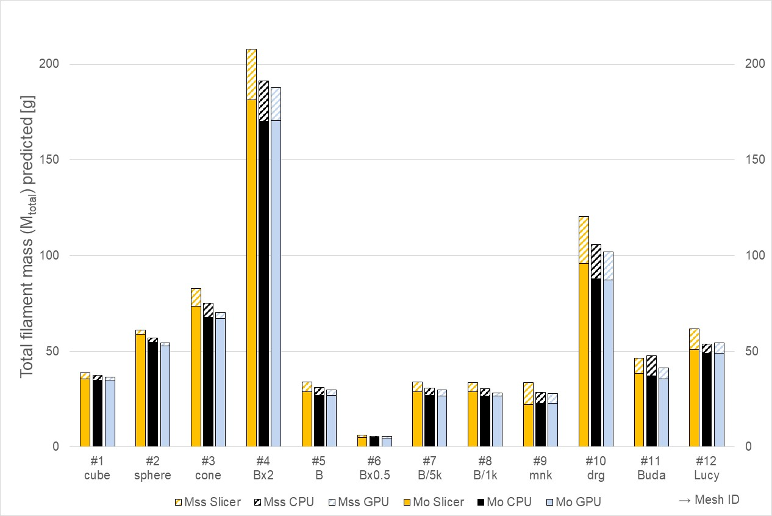

Figure 8. Comparison of total mass predicted at (0°,0°) orientation using slicer SW, CPU-MSST, and GPU-MSST

Assume we must 3D-print a hemisphere shape with radius ***R***. Figure 9 is the schematic view. The red dashed area corresponds to SS, and its volume (***V****hs_ss*) can be calculated from cap volume (***V****cap*) and cap cylinder volume (***V****capcyl*) like Eq. (13)~(15) [18].

$V_{capcyl}={πa^{2}h}$ (13)

$V_{cap}= \frac{1}{3}{πR^{3}(2-3sinθ_{c}+\sin^{3}θ_{c})}$ (14)

$V_{hs_ss}={V_{capcyl}-V_{scap}}$ (15)



Figure 9. The exact support structure volume of the sphere using a sphere cap

Using Eq. (15), the hemisphere’s 3D printing filament mass for any critical angle can be known precisely, as shown in Figure 10's red color. The critical angle varied from 0° to 90° with a 10° interval, and the radius(***R***) was set to 75mm. The meanings of the solid and dashed boxes are the same as in Figure 9, while the dashed boxes (***M****ss*) are displayed on the right-hand side of solid boxes (***M****o*) for comparison. *CPU1* and *GPU1*’s prediction results were also added. The absolute error among the three methods is the same here. However, the Mo values of *CPU1* and *GPU1* are always the same, which means that the *MSST*’s voxelization is independent of g-code conditions or orientations. ***M****ss* values also show the same tendency with ***M****o*.

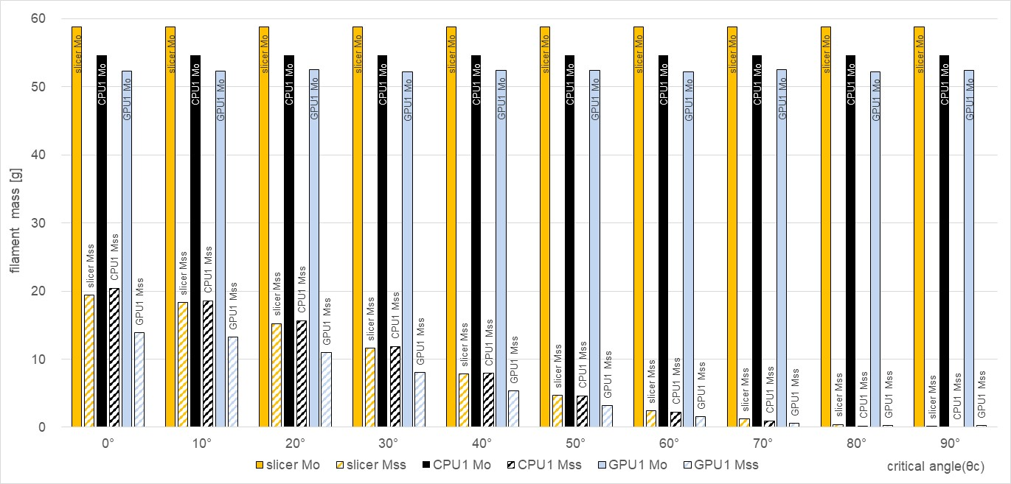

Figure 10. Prediction of filament masses for different filament critical angles

## Optimal orientation search

The previous section showed that the *MSST* can predict filament information with some marginal errors. However, the objective is to find the optimal orientation, not just the absolute mass values of a specific orientation. To verify whether the *MSST* can find orientation information, three methods were applied for the “(4) B_2x” mesh of Figure 7. First, the slicer’s g-code operation was repeated manually, varying X- and Y-axis rotation with 30° intervals. Figure 11a shows the result, in which the bluest and reddest regions mean the optimal and worst orientations, respectively. Figures 11b and c represent the *MSST* results for *CPU1* and *GPU1*, respectively. Although there is a slight difference in the overall distribution, the positions of optimal and worst are the same in all the graphs. Figure 12a and b are the examples of 1st optimal (o1) and 1st worst (w1) orientation from Figure 11c.

|  |  |  |
| --- | --- | --- |
| (a) slicer (interval:30°) | (b) CPU1 (interval:1°) | (c) GPU1 (interval:1°) |

Figure 11. Optimal orientation search results with the three methods for “(4) B_2x”

|  |  |
| --- | --- |
| (a) 1st Optimal orientation (231°,54°), ***M***ss=4.8g | (b) 1st worst orientation (243°,356°), ***M***ss=63.4 g |

Figure 12. Optimal and worst orientation example for Bunny using GPU1-MSST

Conventional slicing SW already provides similar services. However, because of calculation time, its prediction is limited to only several orientations. Our *MSST* method uses a simple voxelization approach instead of complex mesh slicing and g-code generation. Therefore, it only takes tens of seconds, even for a small search angle step such as 1°. Figure 13 shows the calculation time needed for the twelve meshes using six kinds of hardware. The *GPU4*’s time was short, so the vertical axis is a log scale. Note that a 1° interval needs 129,600 iterations of single orientation *MSST*. Therefore, the slicer’s time could be added to this graph. Remarkably, a high-end CPU (*CPU2*) performs better than some low-valued GPU (*GPU1*). The reason would be that the *MSST* does not have the data or algorithm structure the GPU prefers. Nevertheless, the high-end GPUs, such as *GPU4*, show a surprising multi-processing performance; *GPU4* is faster than 10.8 and 44.5 times faster than *CPU2* and *CPU1*, respectively, on average. This means that our GPU-*MSST* can predict an optimal orientation for tens of thousands of triangles in about ten seconds.

The printer user’s choice can reduce the time even more. For example, the bed structure’s volume is generally small and does not affect the optimal orientation search [24]. Table 6 summarizes the single orientation calculation time of GPU-*MSST* for “(5) B”. Therefore, omitting bed structure can save38.3% of the time. Otherwise, the use can reduce the number of mesh triangles in advance, which can be done very easily with CAD software or Python language.

Table 6. Calculation time example of GPU4-MSST functions at (0°,0°) orientation (mesh: “(5) B”)

|  |  |  |
| --- | --- | --- |
| function | Grid x block size | Time [㎲] |
| cu_rotVoxel() | (3298) x (4,4,32) | 33.3 (30.2%) |
| cu_slotPairing() | (4096) x (16,16) | 28.5 (27.6%) |
| cu_genBed() | (256) x (256) | 35.1 (38.3%) |
| cu_reducedSum() | (256) x (256) | 4.4 (4.0%) |
| Σ | - | 101.3 (100.0%) |

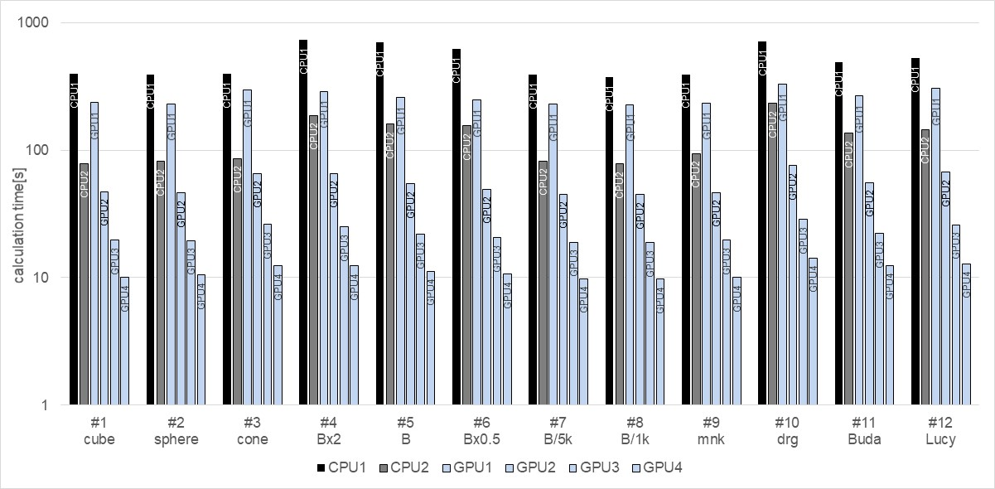

Figure 13**.** Calculation time comparisons of CPU-MSST and GPU-MSST (search angle interval: 1°)

# Conclusions

This paper proposes a GPU-based filament mass information prediction algorithm for 3D printing. It can give detailed mass information for a specific orientation and predict the optimal orientation by repeating the single orientation. Our previous CPU-based algorithm took one to two minutes for tens of thousands of triangles. Using general-purpose GPU calculation, the proposed GPU-*MSST* needed only about ten seconds. There were slight differences in mass values with the slicer’s prediction. However, the errors were independent of orientation and filament critical angle. Twelve kinds of triangular meshes were used for the test. Optimal and worst orientation prediction results were the same as those of slicer software. Despite our efforts, some low-priced GPUs did not show parallel computation power as fast as in deep learning. The reason is that the GPU has several limitations, and our problem is not a perfect form that fits the GPU. Nevertheless, our GPU-*MSST* showed 10 to 45 times faster performance. Our further work will apply the proposed method to an optimal automatic 3D printing of large-sized objects such as human manikins.

**Acknowledgment**: This work was supported by the National Research Foundation of Korea (NRF) grant funded by the Korean government (MSIT) (NRF-2022R1A2C1010072 and NRF-2023R1A2C2005376).

# Appendix

Figures A1 and A2 are examples of sorting pixels for Z-coordinates using CPU and GPU, respectively.



**Figure A1.** CPU source code for pixel vertical sorting algorithm using C++ 11



**Figure A2.** GPU source code for pixel vertical sorting algorithm using NVIDIA CUDA toolkit

# References

1. A. ISO, "ISO/ASTM 52900: 2015 Additive Manufacturing–General Principles–Terminology", in *ASTM F2792-10e1*. 2015.

2. S. C. Joshi and A. A. Sheikh, "3D printing in aerospace and its long-term sustainability"*.* *Virtual and Physical Prototyping*, 2015. **10**, 175-185.

3. F. Bos, R. Wolfs, Z. Ahmed, and T. Salet, "Additive manufacturing of concrete in construction: potentials and challenges of 3D concrete printing"*.* *Virtual and Physical Prototyping*, 2016. **11**, 209-225.

4. A. Perrot, D. Rangeard, and A. Pierre, "Structural built-up of cement-based materials used for 3D-printing extrusion techniques"*.* *Materials and Structures*, 2016. **49**, 1213-1220.

5. J. Pearce, "Applications of open source 3-D printing on small farms"*.* *Organic Farming*, 2013. **1**, 19-35.

6. C. Guo, M. Zhang, and B. Bhandari, "Model building and slicing in food 3D printing processes: a review"*.* *Comprehensive Reviews in Food Science and Food Safety*, 2019. **18**, 1052-1069.

7. I. Badash, K. Burtt, C. A. Solorzano, and J. N. Carey, "Innovations in surgery simulation: a review of past, current and future techniques"*.* *Annals of Translational Medicine*, 2016. **4**.

8. S. V. Murphy and A. Atala, "3D bioprinting of tissues and organs"*.* *Nature biotechnology*, 2014. **32**, 773.

9. F. Rengier, A. Mehndiratta, H. Von Tengg-Kobligk, C. M. Zechmann, R. Unterhinninghofen, H.-U. Kauczor, and F. L. Giesel, "3D printing based on imaging data: review of medical applications"*.* *International journal of computer assisted radiology and surgery*, 2010. **5**, 335-341.

10. T. D. Ngo, A. Kashani, G. Imbalzano, K. T. Nguyen, and D. Hui, "Additive manufacturing (3D printing): A review of materials, methods, applications and challenges"*.* *Composites Part B: Engineering*, 2018. **143**, 172-196.

11. P. Delfs, M. Tows, and H.-J. Schmid, "Optimized build orientation of additive manufactured parts for improved surface quality and build time"*.* *Additive Manufacturing*, 2016. **12**, 314-320.

12. C. Dai, C. C. Wang, C. Wu, S. Lefebvre, G. Fang, and Y.-J. Liu, "Support-free volume printing by multi-axis motion"*.* *ACM Transactions on Graphics*, 2018. **37**, 1-14.

13. C. C. Wang, Y.-S. Leung, and Y. Chen, "Solid modeling of polyhedral objects by layered depth-normal images on the GPU"*.* *Computer-Aided Design*, 2010. **42**, 535-544.

14. P. Das, K. Mhapsekar, S. Chowdhury, R. Samant, and S. Anand, "Selection of build orientation for optimal support structures and minimum part errors in additive manufacturing"*.* *Computer-Aided Design and Applications*, 2017. **14**, 1-13.

15. Q. Xu, H. Jeon, and M. Annavaram. "Graph processing on GPUs: Where are the bottlenecks?". 2014 IEEE International Symposium on Workload Characterization (IISWC), pp.140-149: IEEE, 2014.

16. B. Ezair, F. Massarwi, and G. Elber, "Orientation analysis of 3D objects toward minimal support volume in 3D-printing"*.* *Computers & Graphics*, 2015. **51**, 117-124.

17. J. Y. Jung, S. Chee, and I. H. Sul, "Support structure tomography using per-pixel signed shadow casting in human manikin 3D printing"*.* *Fashion and Textiles*, 2022. **9**, 1-18.

18. J. Y. Jung, S. Chee, and I. Sul, "Prediction of optimal 3D printing orientation using vertically sparse voxelization and modified support structure tomography"*.* *International Journal of Clothing Science and Technology*, 2023. **35**, 799-832.

19. T. Wu, S. He, J. Liu, S. Sun, K. Liu, Q.-L. Han, and Y. Tang, "A brief overview of ChatGPT: The history, status quo and potential future development"*.* *IEEE/CAA Journal of Automatica Sinica*, 2023. **10**, 1122-1136.

20. C. Zhang, C. Zhang, S. Zheng, Y. Qiao, C. Li, M. Zhang, S. K. Dam, C. M. Thwal, Y. L. Tun, and L. L. Huy, "A complete survey on generative ai (aigc): Is chatgpt from gpt-4 to gpt-5 all you need?"*.* *arXiv preprint arXiv:2303.11717*, 2023.

21. E. Nurvitadhi, D. Sheffield, J. Sim, A. Mishra, G. Venkatesh, and D. Marr. "Accelerating binarized neural networks: Comparison of FPGA, CPU, GPU, and ASIC". 2016 International Conference on Field-Programmable Technology (FPT), pp.77-84: IEEE, 2016.

22. I. Buck, "Gpu computing with nvidia cuda", ACM SIGGRAPH 2007 courses, 2007. Vol., pp.6-es.

23. J. Y. Jung, S. Chee, and I. H. Sul, "Prediction of optimal 3D printing orientation using vertically sparse voxelization and modified support structure tomography"*.* *Internationl Journal of Clothing Science and Technology*, 2023. **35**, 799-832.

24. J. Y. Jung and I. H. Sul, "Prediction of 3D Printing Bottom Plate Amount Using Open Source Software and Support Structure Tomography"*.* *Textile Science and Engineering*, 2023. **60**, 249-255.

25. J. Y. Jung and I. H. Sul, "Prediction of Filament Usage in Human Manikin 3D Printing Using Voxel Approximation-based Shadow Projection"*.* *Textile Science and Engineering*, 2022. **59**, 79-87.

26. M. Khairy, A. G. Wassal, and M. Zahran, "A survey of architectural approaches for improving GPGPU performance, programmability and heterogeneity"*.* *Journal of Parallel and Distributed Computing*, 2019. **127**, 65-88.

27. S. Filippone, V. Cardellini, D. Barbieri, and A. Fanfarillo, "Sparse matrix-vector multiplication on GPGPUs"*.* *ACM Transactions on Mathematical Software (TOMS)*, 2017. **43**, 1-49.

28. B. He, N. K. Govindaraju, Q. Luo, and B. Smith. "Efficient gather and scatter operations on graphics processors". Proceedings of the 2007 ACM/IEEE Conference on Supercomputing, pp.1-12, 2007.

29. M. Harris and M. Garland, "Optimizing parallel prefix operations for the Fermi architecture", GPU Computing Gems Jade Edition, Elsevier, 2012. Vol., pp.29-38.

30. J. A. Slotwinski and S. Moylan, "Applicability of existing materials testing standards for additive manufacturing materials", US Department of Commerce, National Institute of Standards and Technology …, 2014.